4. VACUUM CLEANER PROBLEM

Aim:
To develop a Python program that simulates the Vacuum Cleaner Problem using a simple reflex agent to clean all dirty rooms.

Objective :
- To understand the working of a simple reflex agent.
- To simulate the behavior of a vacuum cleaner in an environment.
- To clean dirty rooms based on their current state.
- To display the actions performed by the vacuum cleaner.

Algorithm:

- Start.
- Define the environment with two rooms (A and B).
- Set the initial location of the vacuum cleaner.
- Check the current room.
- If the room is dirty:
- Clean the room.
- Otherwise:
- Move to the next room.
- Repeat until both rooms are clean.
- Display the final state of the rooms.
- Stop.

Flowchart :

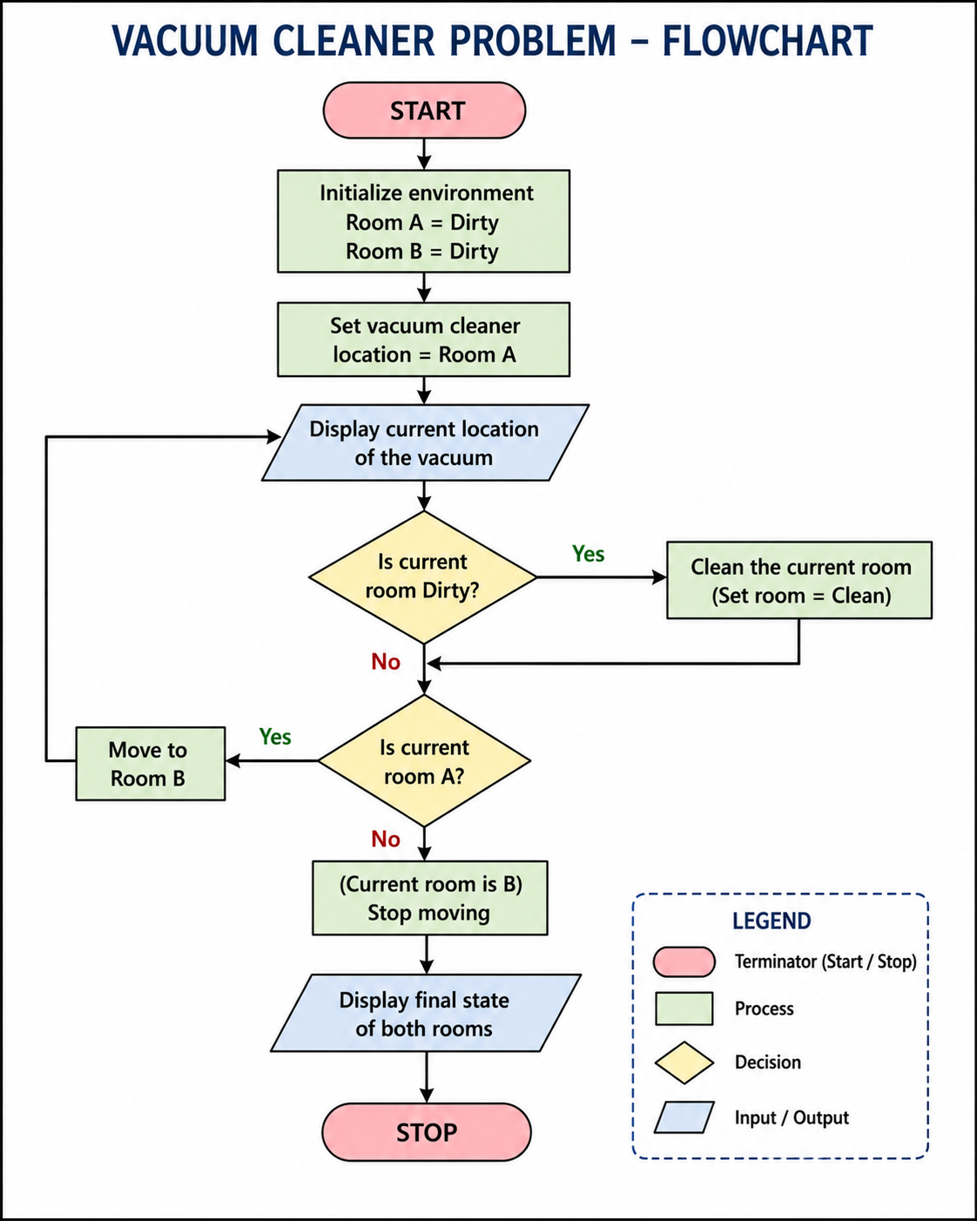

Code:
rooms = {
"A": "Dirty",
"B": "Dirty"
}
location = "A"
while True:
print("\nVacuum is in Room", location)
if rooms[location] == "Dirty":
print("Cleaning Room", location)
rooms[location] = "Clean"
if location == "A":
location = "B"
else:
break
print("\nFinal State")
for room in rooms:
print("Room", room, ":", rooms[room])
print("\nAll rooms are clean.")
Output:
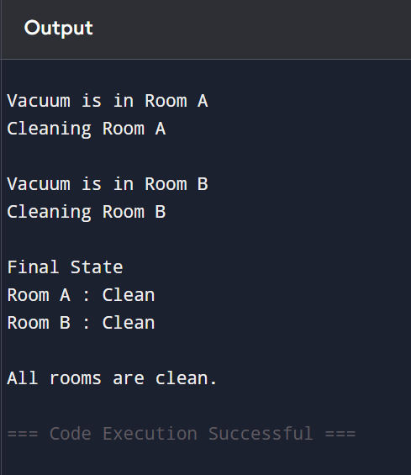
Result :
The Vacuum Cleaner Problem was successfully implemented using Python. The vacuum cleaner visited each room, cleaned the dirty rooms, and finally ensured that all rooms were clean.

